**Individual Weekly Report**

**Name: Paul Bae**

**Team:** Good AIM

**Date:** 02/03/2025

| **Current Status** |
| --- |

1. What did you **personally** work on this past week?

| **Task** | **Status** | **Time Spent** |
| --- | --- | --- |
| Project Report | Completed | 1 hour |
| Team setup/organization | Completed | 30 min |
| Meetings | Completed | 1 hour |
| Requirements/User Story Generation | Ongoing | 2.5 hours |
| Lo-Fi Designs | Ongoing | 30 min |
| Transcribing feedback and ideas | Completed | 30 min |

Include **screenshots/graphics** to illustrate what you did this past week:

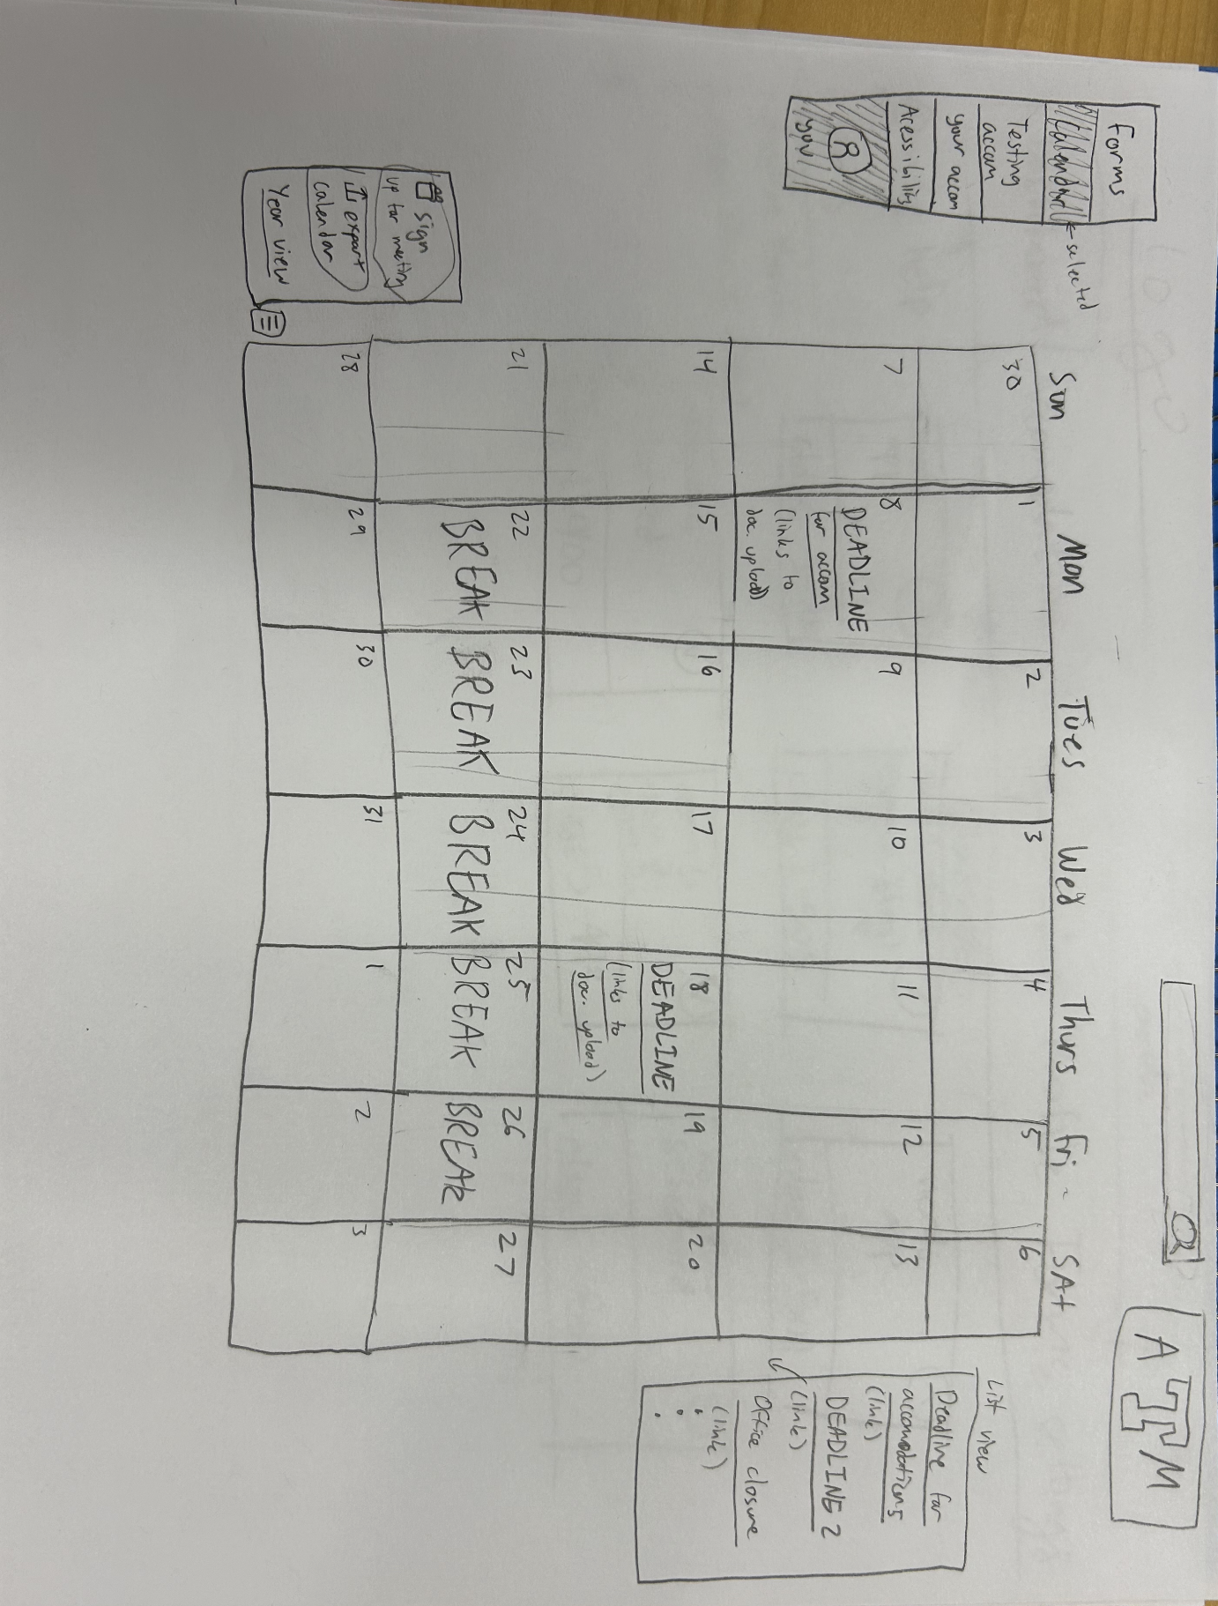

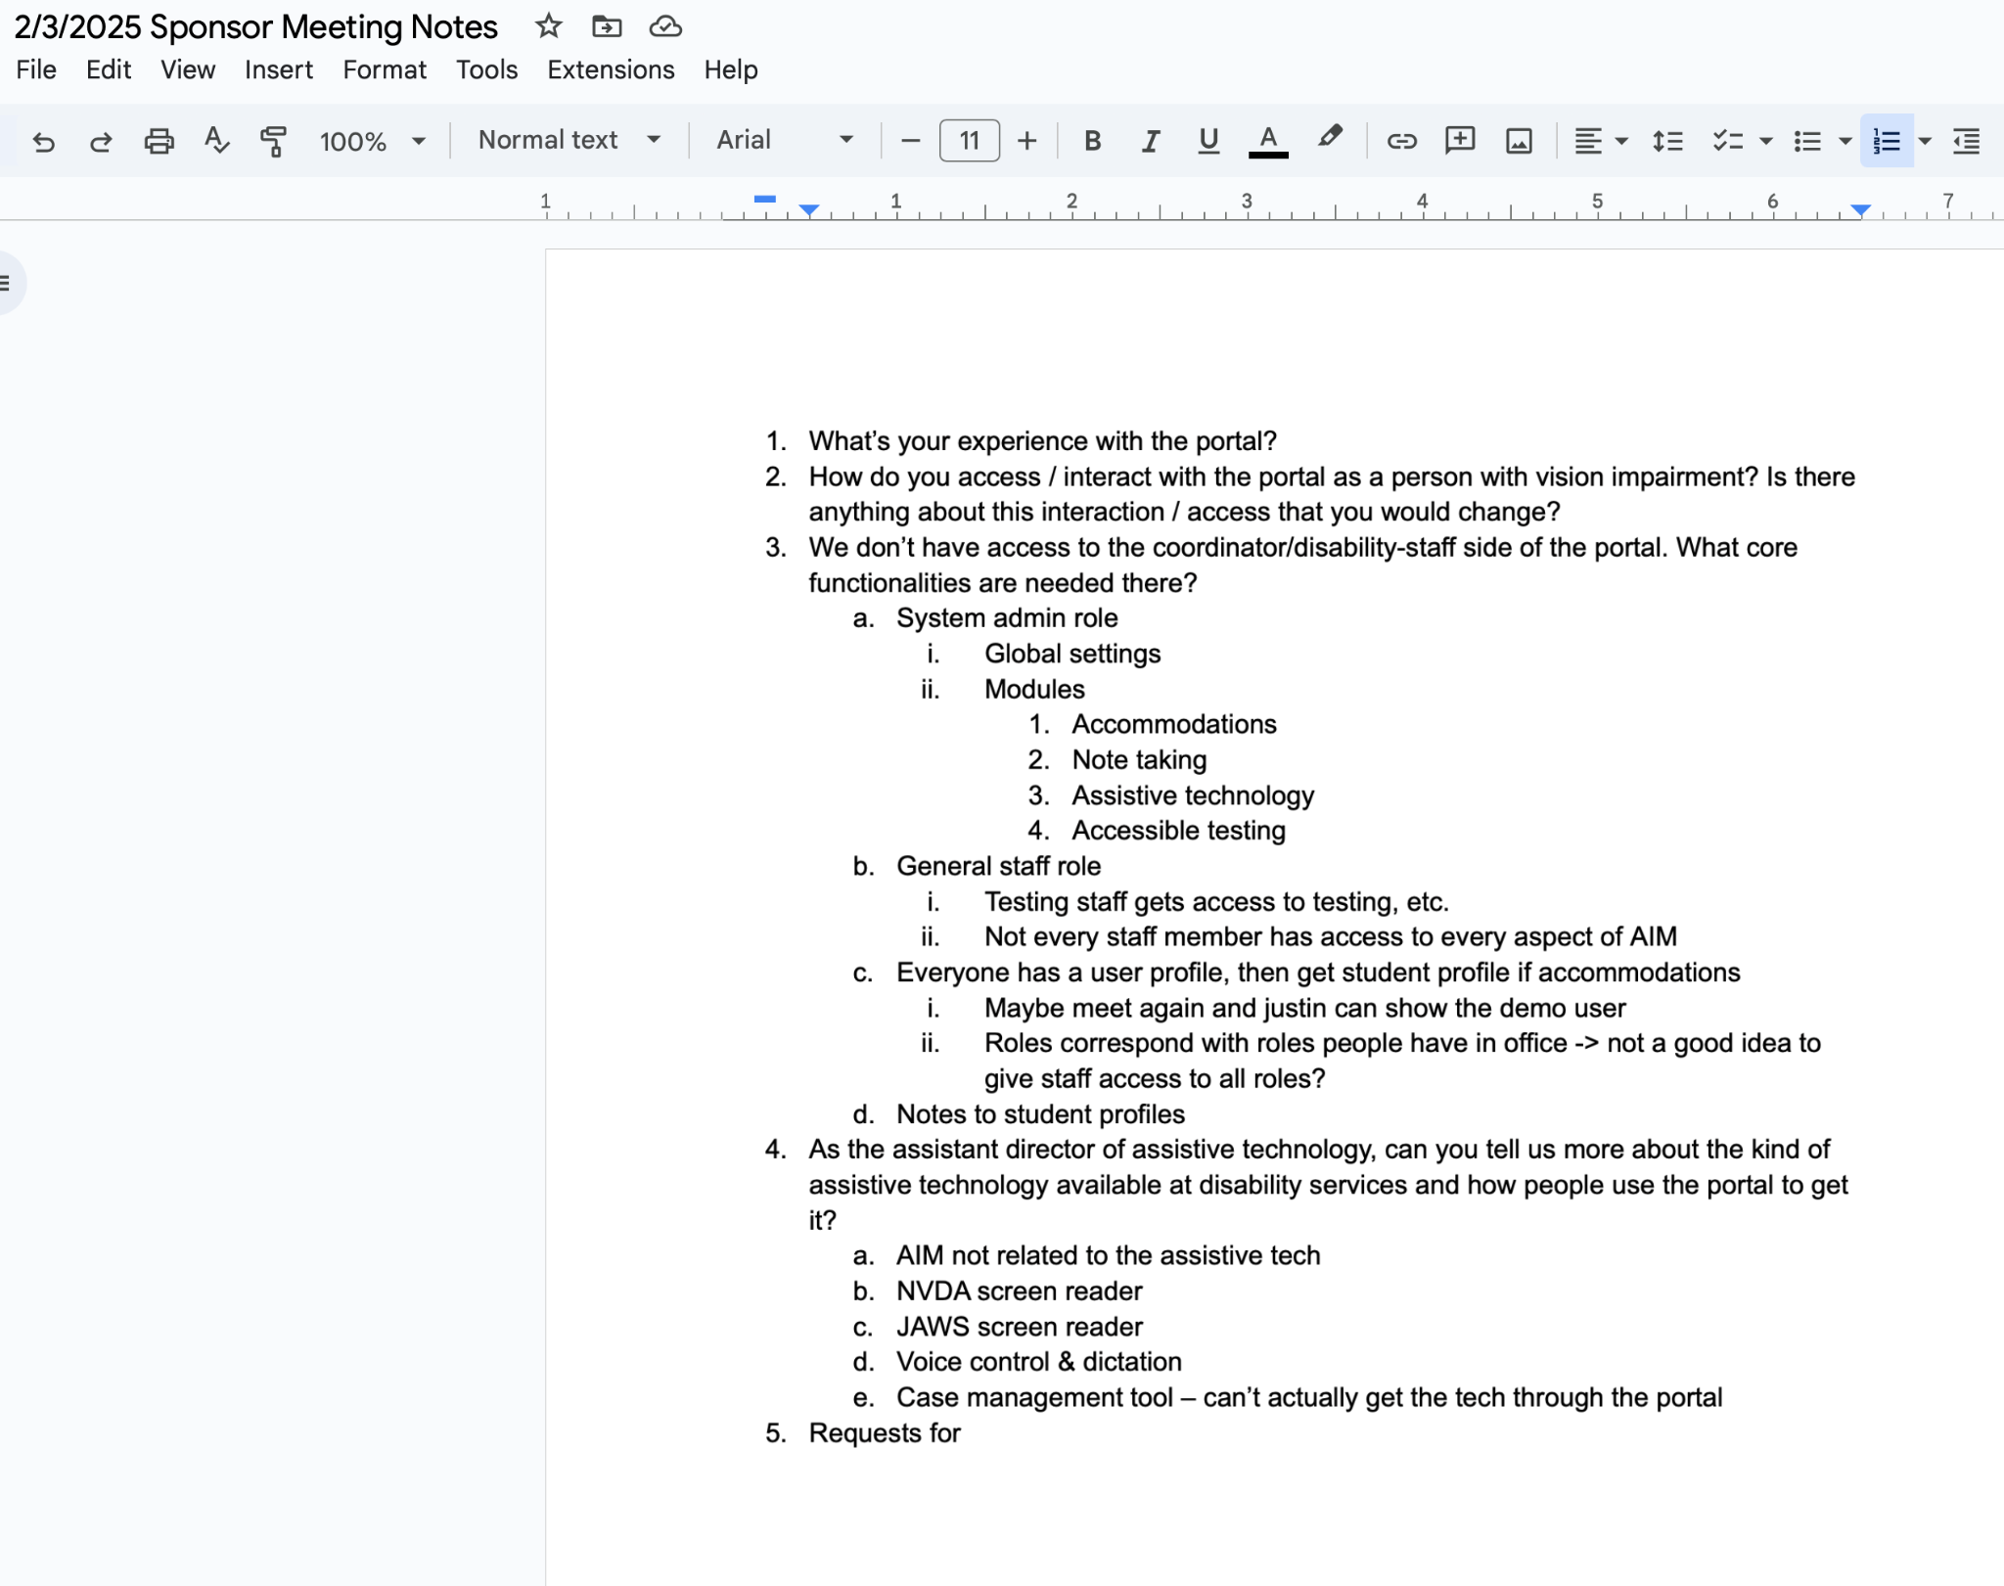

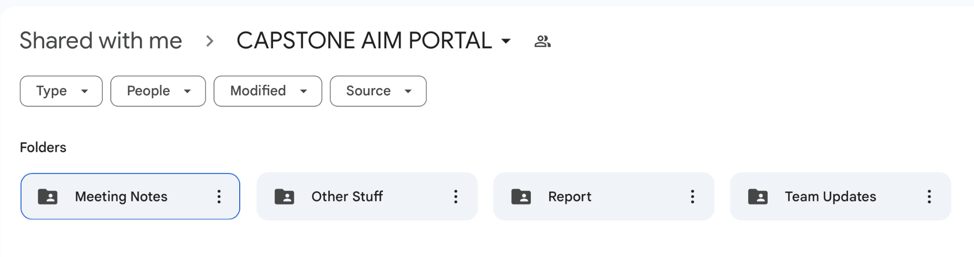

1. What problems did you run into? What is your plan for them?

One problem we ran into was the feedback we received from Dan Darkow, from the actual AIM portal, who was very rude in telling us that our project was being done already by the official company. We will continue with the project, as planned, and create a better looking and more accessible website than AIM.

1. What is the current overall project status from your perspective?

We are done with all the design and ideation for this project. We are using an agile methodology, so the project will create more requirements as we go. Starting today, we will create and setup the coding portion of this project.

1. How is your team functioning from your perspective?

Unfortunately, our team has been having issues with attendance, creating discrepancies in communication. To remedy this, we will start reminding and encouraging team members to come to class.

1. What new ideas did you have or skills did you develop this week?

We were able to take ideas and features that we were inspired by in other teams and add them to our own project, and the feedback from pilot studies was extremely helpful in allowing us to shift creatively from one lead design idea to another.

1. Who was your most awesome team member this week and why?

Definitely Simone Kang. She reached out the most to the sponsor, AIM, etc. and set up the github repository as well as split up assignments in the project reports.

| **Plans for Next Week** |
| --- |

What are you going to work on this next week?

I will set up the database, set up the jira board, do the project report, ethics course, etc.